|  |  |
| --- | --- |
| Date: | 09/20/2012 |
| Name: | Mark Evans |
| Course: | APD |
| Director: | Wendy Jones |
| document: | Application Design Document |
| [Recipe It Up!] | |

Application Definition Statement

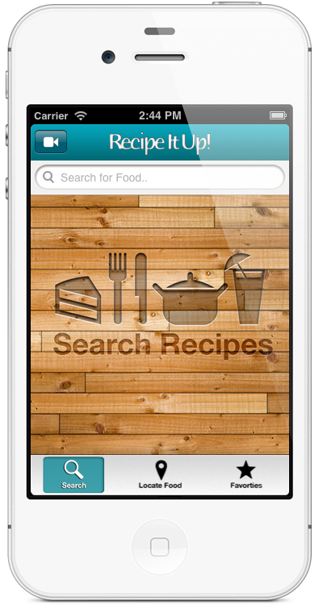A concise, concrete declaration of the application’s main purpose and its intended audience

|  |
| --- |
| Purpose or Main Intent |
| An app that allows users to find recipes for appetizers, entrees, desserts, and mixed drinks. |
| Description of Intended Audience |
| Anyone that has a passion for cooking or a need for a mix drink. |
| Core Functionality |
| To allow users to find a recipe via a search with the added ability to save a particular recipe within in the app. The user will also have the ability to print and/or email them. |

Application User Feature Set

A list of features from the user’s perspective

# Core Function

* Application enables user the ability to find a recipe.
* Users will be able to save recipes within application.

Available Information

* Find Recipe view will allow user to search for a recipe on the main view.
* Find Recipe list view will show the recipe results on a table view, selected recipe will show the Detail view. This view also includes an edit button that allows the user to save a recipe. An alert will show when a recipe is added.
* Detail view will provide an image of selected recipe. The view will also have two buttons, one will allow the user to email the recipe link, and the other button will allow the user to open a web view with instructions how to prepare the recipe.
* Email view will show populated information in the message body including the recipe title, and link to recipe source.
* Web view will show recipe instructions and have the ability to print, go forward, back, refresh, and stop.
* Saved Recipe view will allow the user to view a list of recipes that have been saved on a table view, selected recipe will show the Detail view. This view also includes an edit button that allows the user to delete a saved recipe. An alert is show when a recipe is deleted.
* Food Search view allows the user to look for nearby food locations or items via the Map View. User will also be able to click on an annotation and open the Google Maps for directions.

# Notification

* When user exits the application, a notification will be sent to inform them of its presence.

# Special of the Week

* Will show a video presentation of how to make a particular recipe.Application Layout

The Layout of the Application

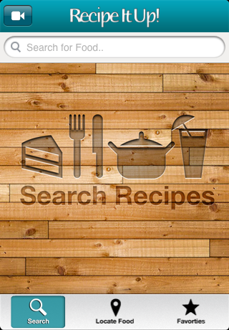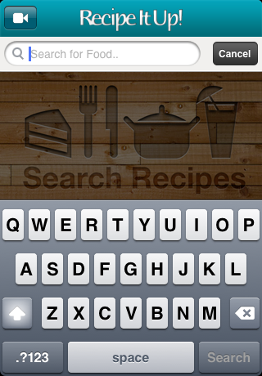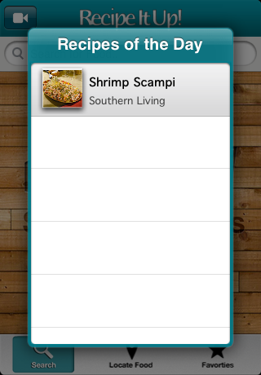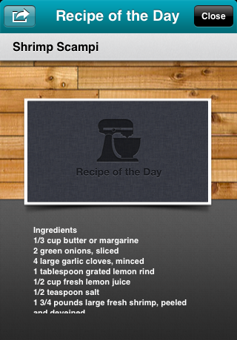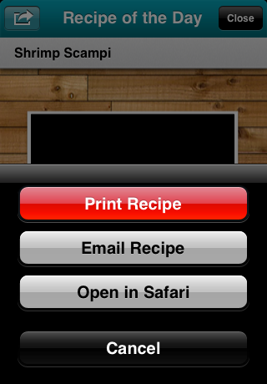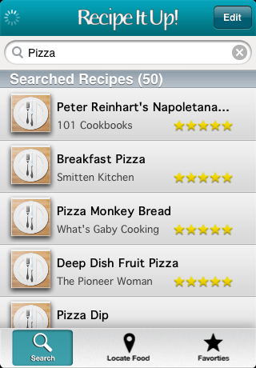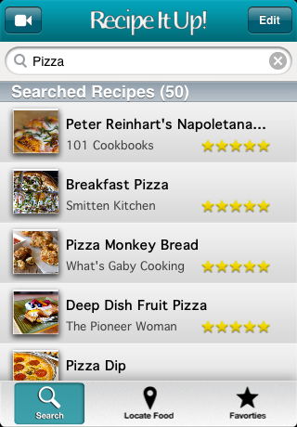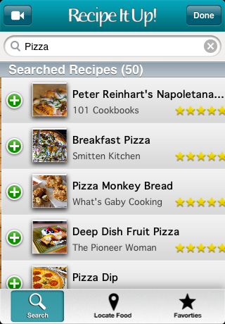

# (Additional UI Screens)

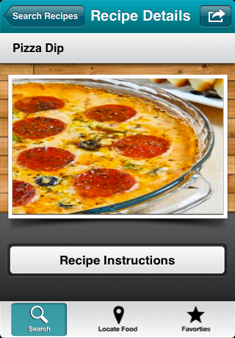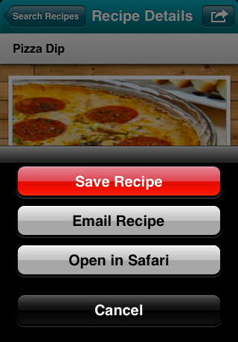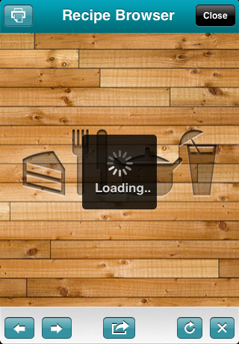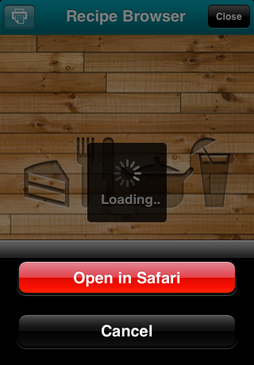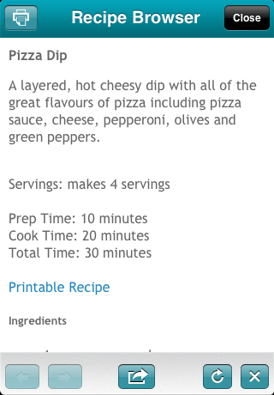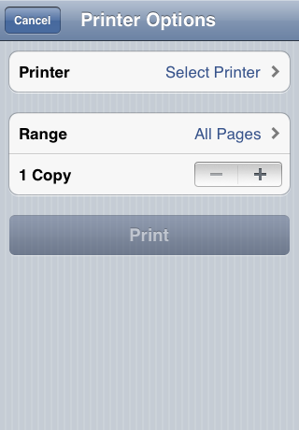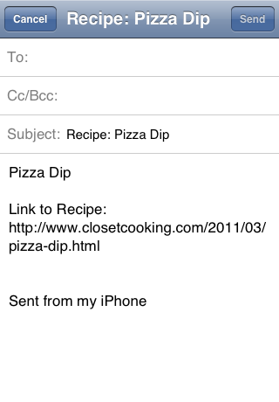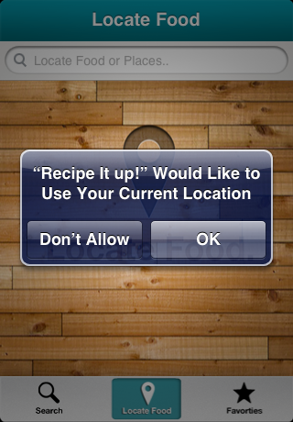

# (Additional UI Screens)

# 

# 

# (Additional UI Screens)

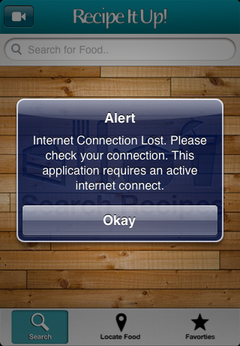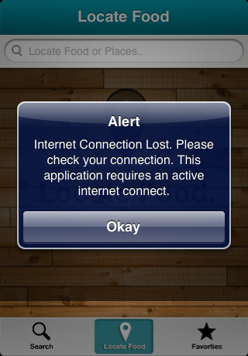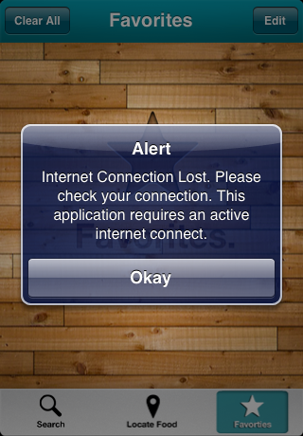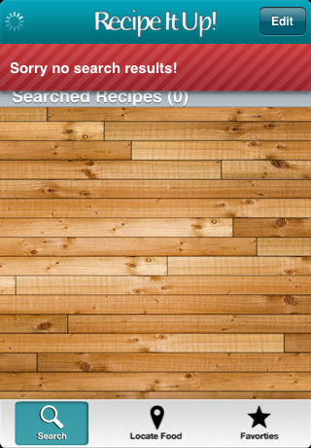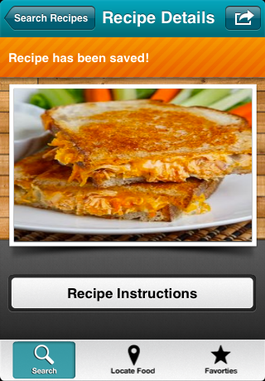

Application Flow

UIAlertView

(No Internet)

Locate Food Tab

Title screen

The Flow of UI through the Application

Tab Bar Controller

(Create a full flow chart of your application including connections)

MKMapView (Map of Food Locations)

UISearchBar (Search food locations)

Action Sheet (Email)

Action Sheet (Save)

DetailsViewController

(Detail view of Recipe)

UISearchBar (Search for Recipes)

Favorites Tab

WebView Loading Screen

WebView Loading Screen

UIAlertView

(No Internet)

UIToolbar-(Back, Forward, Stop, and Refresh buttons)

UIToolbar-(Back, Forward, Stop, and Refresh buttons)

UIAlertView

(No Internet)

UIAlertView

(Empty search field or No Internet)

PrintView Controller

WebViewController

(WebView for Recipe instructions)

EmailViewController

(Email View with populated Recipe data)

Action Sheet (Email Recipe)

UIButton

(Recipe Instructions)

PrintView Controller

WebViewController

(WebView for Recipe instructions)

EmailViewController

(Email View with populated Recipe data)

UIButton

(Recipe Instructions)

Alert

Delete Recipe Notification

DetailsViewController

(Detail view of Recipe)

Table Cell Delete Button

(Minus Recipe Button)

UIBarButton

(Edit Button)

SavedViewController

UITableView (Saved Recipes)

Alert

Save Recipe Notification

Table Cell Plus Button

(Add Recipe Button)

UIBarButton

(Edit Button)

VideoViewController

(Video with built in controls)

ResultsViewController

UITableView (Search Recipe Results)

UIBarButtonItem

(Recipe Video)

Search Recipe Tab